Week2 Mini Project

Question:

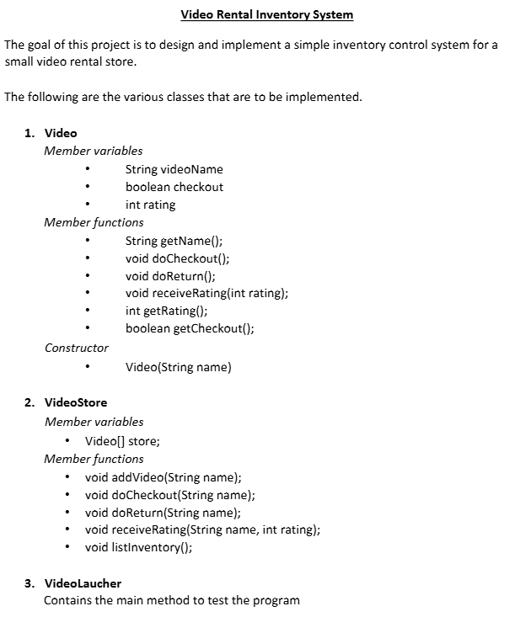

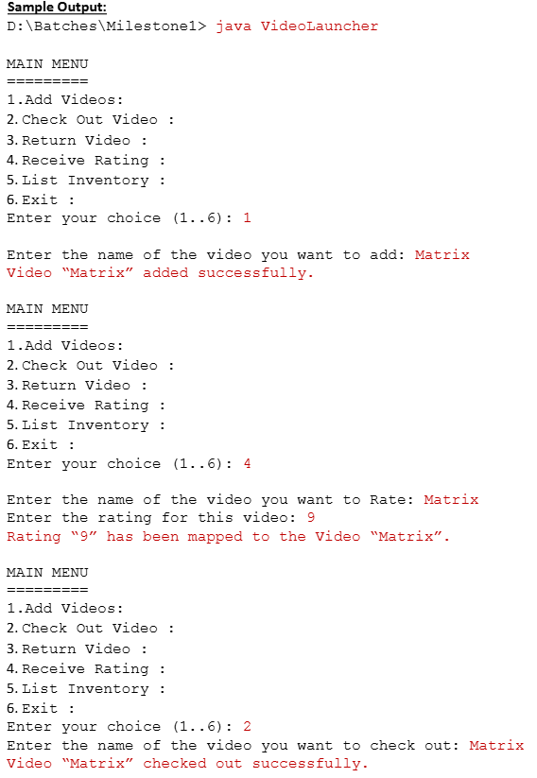

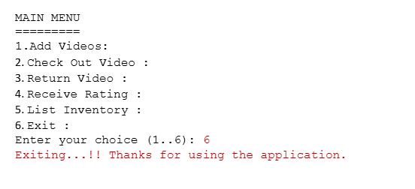

Video.java

package week2;

public class Video

{

String videoname;

boolean checkout;

int rating;

Video(String name)

{

videoname=name;

}

String getName()

{

return videoname;

}

int getRating()

{

return rating;

}

boolean getCheckout()

{

return checkout;

}

void docheckout()

{

checkout=true;

}

void doReturn()

{

checkout=false;

}

void receiveRating(int rating)

{

this.rating=rating;

}

}

VideoStore.java

package week2;

public class VideoStore

{

Video[] store;

int checkvideo(String name)

{

int flag=0;

for(Video v:store)

{

if(v.getName().equals(name))

{

flag=1;

}

}

return flag;

}

void addvideo(String name)

{

int size;

Video v=new Video(name);

try

{

size=store.length;

}

catch(Exception e)

{

size=0;

}

Video[] newStore=new Video[size+1];

newStore[size]=v;

store=newStore;

}

void docheckout(String name)

{

if(store==null||store.length==0)

{

System.***out***.println("Store is empty");

}

for(Video v:store)

{

if(v.getName().equals(name))

{

v.docheckout();

}

}

}

void doReturn(String name)

{

if(store==null||store.length==0)

{

System.***out***.println("Store is empty");

}

for(Video v:store)

{

if(v.getName().equals(name))

{

v.doReturn();

}

}

}

void receiveRating(String name, int rating)

{

if(store==null||store.length==0)

{

System.***out***.println("Store is empty");

}

for(Video v:store)

{

if(v.getName().equals(name))

{

v.receiveRating(rating);

}

}

}

void listInventory()

{

if(store==null||store.length==0)

{

System.***out***.println("Store is empty");

}

for(Video v:store)

{

System.***out***.print("===========================================================================");

System.***out***.printf("\n\t%-20s\t|\t%-10s\t|\t%-15s\n","Video Nmame","Checkout Status","Rating");

System.***out***.printf("\n\t%-20s\t|\t%-10s\t|\t%-15s\n",v.getName(),v.getCheckout(),v.getRating());

System.***out***.println("---------------------------------------------");

}

}

}

VideoLancher.java

package week2;

import java.util.*;

public class VideoLancher

{

public static void main(String args[])

{

Scanner sc=new Scanner(System.***in***);

int ch;

System.***out***.println("/n1.Add videos/n2.check out video"+"/n"+"3.Return the video"+"/n"+"4.recieve rating"+"/n"+"5.List Inventory"+"/n"+"6.Exit");

System.***out***.println("enter the choice");

ch=sc.nextInt();

VideoStore vs=new VideoStore();

while(ch!=6)

{

String name;

sc.nextLine();

switch(ch)

{

case 1:

System.***out***.println("enter the name of video you want to Add");

name=sc.nextLine();

vs.addvideo(name);

System.***out***.print("video"+name+" added succesfully.");

break;

case 2:

System.***out***.println("enter the video you want to check out");

name=sc.nextLine();

if(vs.checkvideo(name)==0)

{

System.***out***.print("video does not exist");

}

else

{

vs.docheckout(name);

System.***out***.print("video"+name+" checked out successfully");

}

break;

case 3:

System.***out***.println("enter the video you want to Return");

name=sc.nextLine();

if(vs.checkvideo(name)==0)

{

System.***out***.print("video does not exist");

}

else

{

vs.doReturn(name);

System.***out***.print("video"+name+" returned out successfully");

}

break;

case 4:

System.***out***.println(" enter the name of the video you want to rate");

name=sc.nextLine();

if(vs.checkvideo(name)==0)

{

System.***out***.print("video does not exist");

}

else

{

System.***out***.print("enter the rating for the video");

int ra=sc.nextInt();

vs.receiveRating(name,ra);

System.***out***.print("Rating"+ra+" has been mapped to video"+name+".");

}

break;

case 5:

vs.listInventory();

break;

default:

System.***out***.println("Exiting....!! thanks for using the application");

break;

}

}

}

}